Monorepo with Nx and Lerna

In this document you will get quick into what is Nx and Lerna and steps how to create monorepo with NX and Lerna.
In monorepo Nx is used for code generation, easy builds, running tasks, serving and testing application. You can also see dependency graph. Lerna gives support for packaging and versioning.

Mono repo
A monorepo is a single repository containing more than one project (in contrast to the single-repository-per-project approach).

Nx
Nx is a set of extensible dev tools for monorepos. It has support for many frontends and backend technologies. One of the technologies that supports is Angular.

Nx give you:

• Faster command execution

• Code Generation (components, apps, libraries)

• Depedeny graph generation

• You can see what is affected by your change in the code

• Easy Building, running tasks, serving and testing application

Nx wokspace
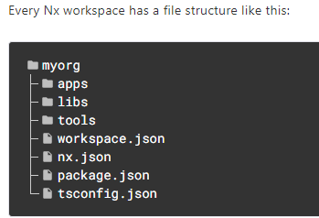
/apps/ contains the application projects. These are the main entry point for a runnable application.
/libs/ contains the library project

For more info visit: https://nx.dev/

Lerna
A Mono-Repo hosts one or more projects or packages. These packages are "Mini-Repos" that can be versioned, built, and published independently. Therefore, every package contains its own package.json file due to the fact that every package is a full-fledged project on its own. Packages might have dependency relations between each other. Managing these dependencies are implemented by symlinks. To get support for automating such manual tasks Lerna was introduced.
Lerna also suports versionig and publising.

Managing dependencies
To get support for automating dependency management you need lerna.json file in the root folder.
Within lerna.json you need to specify where lerna has to look for packages. Every package must have package.json file due to the fact that every package is a full-fledged project on its own. Packages might have dependency relations between each other. Managing these dependencies are automated by Lerna who is in background creating symlinks.
Every lerna workspace has a file strucure like this:
myRepo/
lerna.json
package.json
packages/
package-1/
package.json
package-2/
package.json
Example of lerna.json file
{
"packages": [
"packages/*"
],
"version": "fixed",
"command": {
"publish": {
"conventionalCommits": true,
"yes": true
},
"version": {
"message": "chore(release): publish %v [skip travis]"
}
}
}

There are two mods
- Common dependencies will be installed only to the top-level node_module
- packages will get normal, local node_modules
For more info : https://github.com/lerna/lerna/blob/master/doc/hoist.md

Versionig
Versioning and publishing are important development topics where lerna also shines. lerna allows you to use two versioning modes:
- Fixed/locked mode: The version of each package can be managed at a single point (in lerna.json file). If a package has been updated since the last time a release was made, it will be updated to the new version. As a consequence, a major change in any package will result in all packages having a new major version.
- Independent mode: Package versions can be incremented independently of each other. Therefore, the "version" key inside of lerna.json needs to be set to "independent". This approach provides much more flexibility and is especially useful for projects with loosely coupled components.
For more info on lerna visit https://github.com/lerna/lerna

Create mono repo with Nx and Lerna
First part of the job is to create Nx workspace. Second part is to configure lerna.json file.

Create Nx workspace
Run npx create-nx-workspace@latest.
For more info see https://nx.dev/latest/angular/tutorial/01-create-application

Set up Lerna
In root folder of application create lerna.json
Within you need to set up where packages are located and that is it. Do not forget every package must have package.json file.

Example
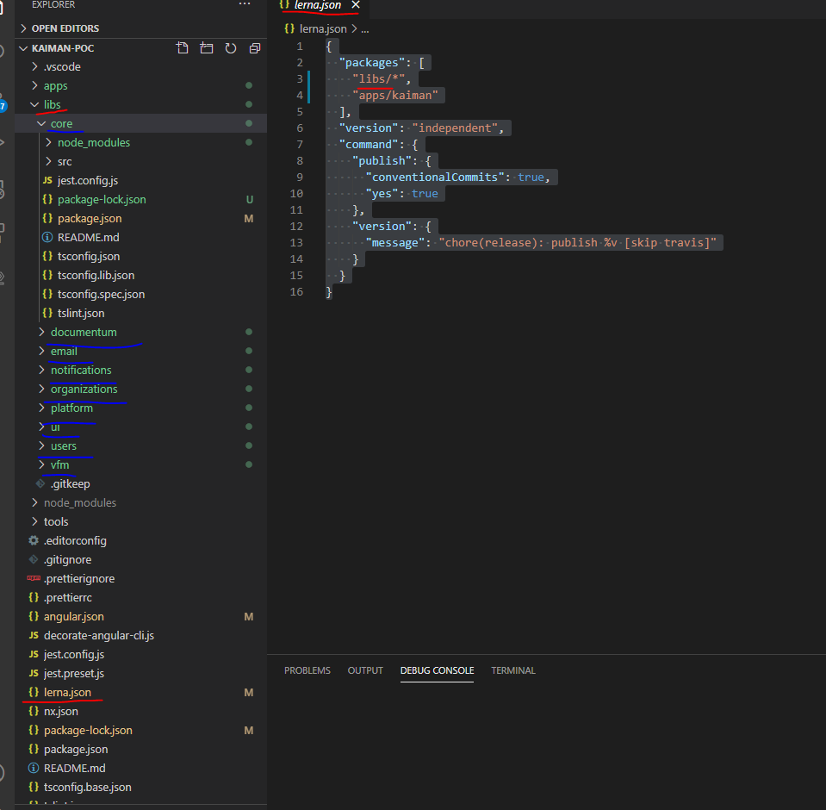
lerna.json is in the root of the project.
Within are packageges declared to be in libs folder and apps/kaiman folder.
You can see that we have core, documentum, email, organizations, platform, ui, users, and vfm libraries and aplication in the apps/kaiman. Every library has package.json file.

